1.

|  |  |  |
| --- | --- | --- |
| Rules | 80% | not 80% |
| fewer than 400 units are sold | 1,50% | 0,50% |
| between 400 and 499 units are sold | 2,50% | 1,50% |
| 500 or more units are sold and the salesperson has been with the company for more than one year | 4,50% | 3,50% |
| 500 or more units are sold and the salesperson has been in the company for one year or less | 3,50% | 2,50% |

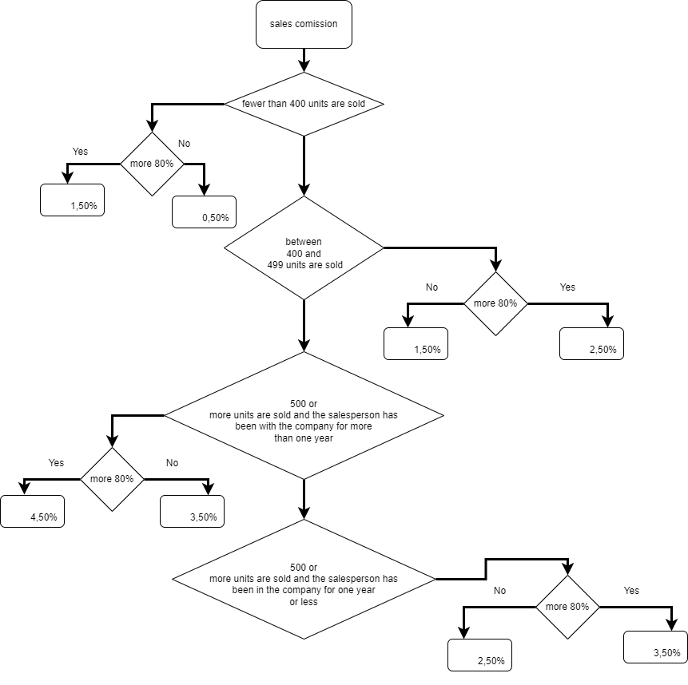

2.

